How to Download and Install Office Pro Plus for Mac
- Go to https://portal.office.com/Home and log in to Office 365
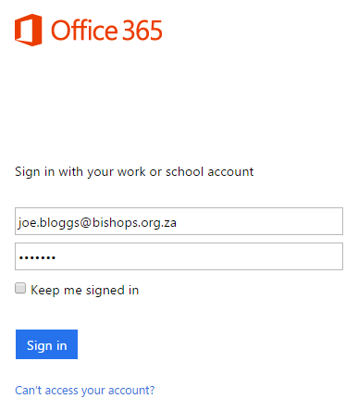
- Access the Settings Menu by clicking on the button and select Office 365 settings from the drop down menu
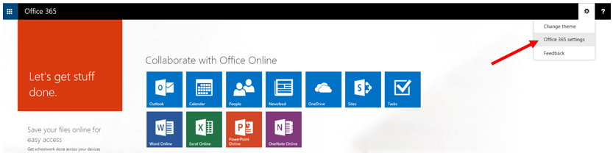

- Select Software
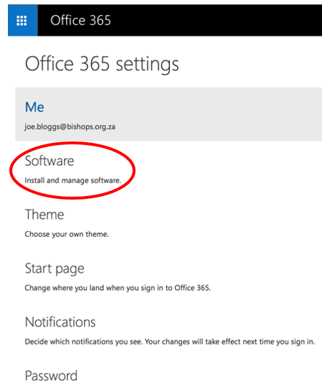

- Click on the Install button
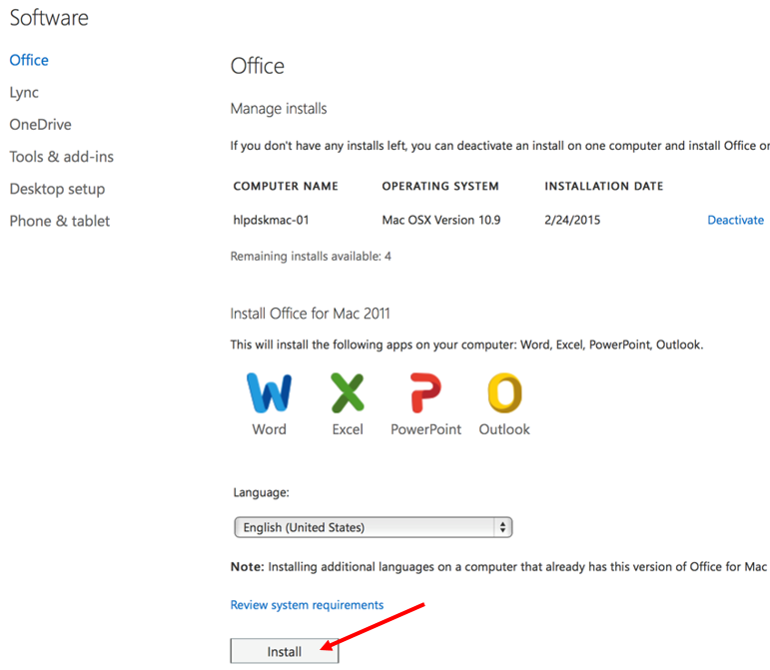

Office 365 Support offers technical support in English 24 hours a day, 7 days a week. Should you experience any difficutlies, please their helpline on 080 020 2883. Alternatively, you may use 021 427 3315 but local call charges will apply.
Online help is also available here.

