How to Download and Install Office Pro Plus for iPads
- Go to the App Store
- Search for Word
- Sign in with your Apple ID and password
- Click on GET and then INSTALL
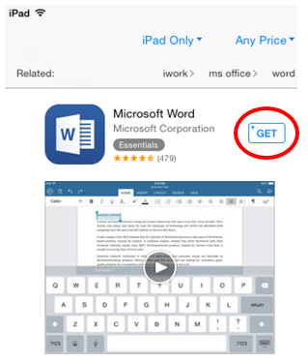

- Sign in with your Office 365 user name and password
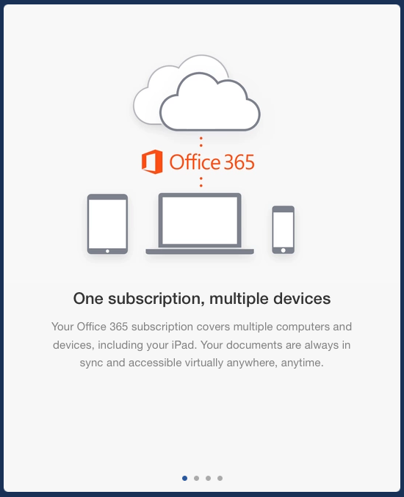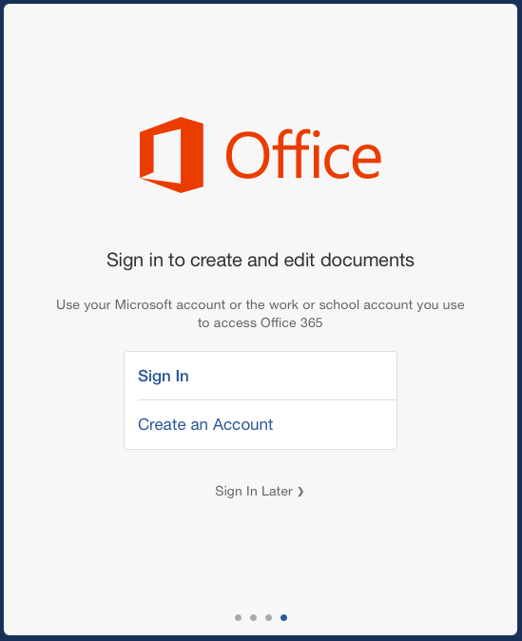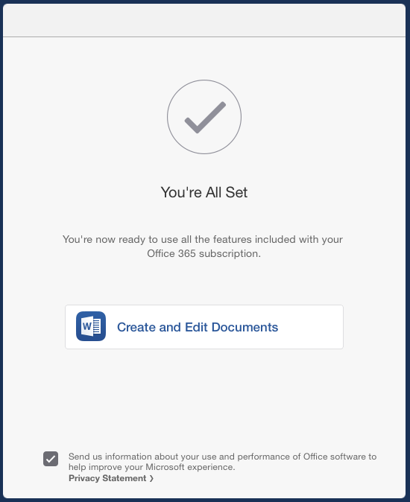
Online help is also available here.

