If you do not have Microsoft Office loaded on your home PC you are welcome to download and install Office Pro Plus. However, please note: downloading Office Pro Plus onto a device that already has Microsoft Office installed will overwrite the original Microsoft Office Suite.
How to Download and Install Office Pro Plus for Windows
- Go to https://portal.office.com/Home and log in to Office 365
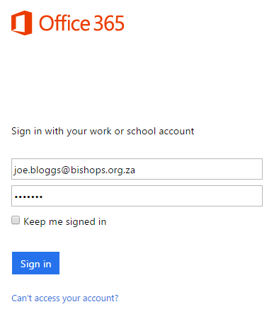

- If you are asked to choose a Time Zone, please select (UTC +02:00) Harare, Pretoria
- Access the Settings Menu by clicking on the button and select Office 365 settings from the drop down menu

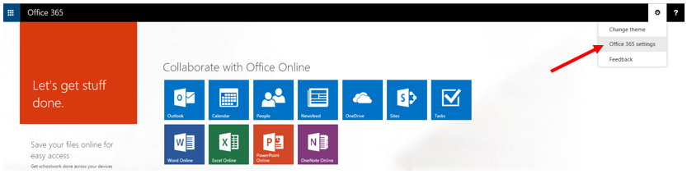
- Click on Software
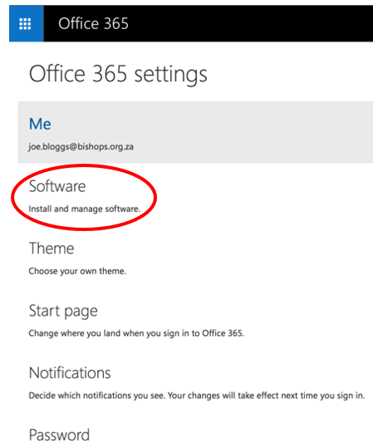
- Click on the Install button
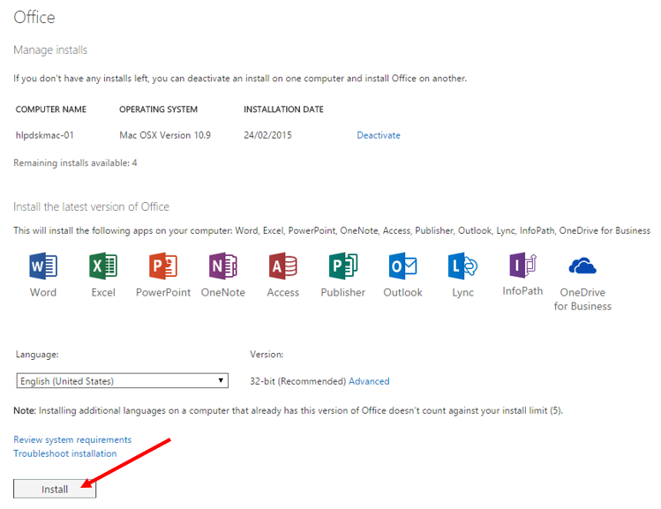
Online help is also available here.

