How to Access the Online Microsoft Office Suite i.e. from any device anywhere in the world
- Go to https://portal.office.com/Home and log in to Office 365

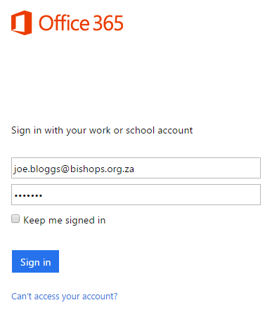
- If you are asked to choose a Time Zone, please select (UTC +02:00) Harare, Pretoria
- Click on the Office 365 Application button (Top left hand corner of the screen)
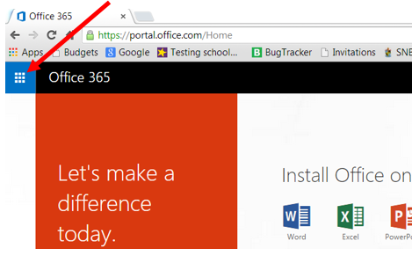

- Select the Application you wish to use
For example, click on Outlook to access your email or OneDrive to view your shared files or to save files to the cloud
